Priority ERP Sales Schema

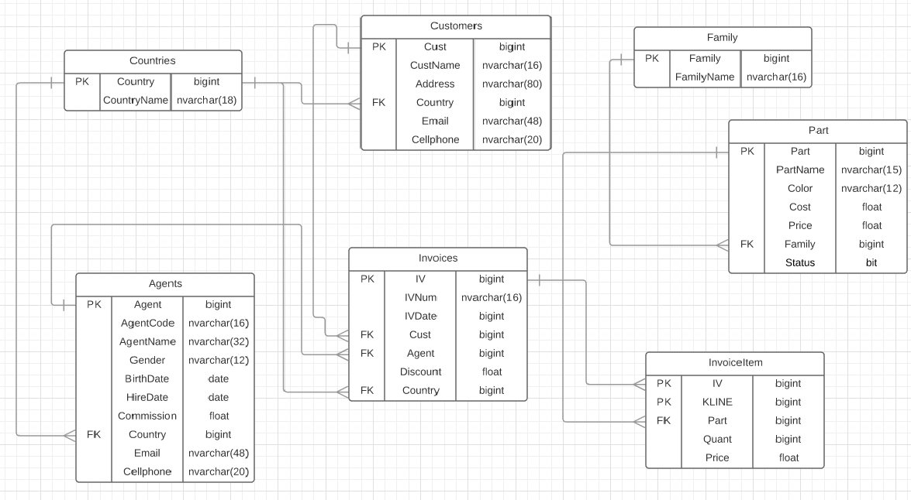

Tables

|  |
| --- |
| Part.Part |
| Part.PartName |
| Part.Cost |
| Part.Price |
| Part.Family |
| Family.Family |
| Family.FamilyName |
| Customers.Cust |
| Customers.CustName |
| Customers.Address |
| Customers.Country |
| Customers.Email |
| Customers.CellPhone |
| Countries.Country |
| Countries.CountryName |
| Agents.Agent |
| Agents.AgentCode |
| Agents.AgentName - FullName |
| Agents.AgentName - FullName |
| Agents.Commission |
| Agents.Country |
| Agents.Email |
| Agents.Cellphone |
| Invoices.IV |
| Invoices.IVNum |
| Invoices.IVDate |
| Invoices.Cust |
| Invoices.Agent |
| Invoices.Discount |
| Invoice.Country |
| InvoiceItems.KLINE |
| InvoiceItems.Part |
| InvoiceItems.Quant |
| InvoiceItems.Price |